IS 1901: Microcontroller based ICT Project
Buddy Bot
Interim Report

Supervisor: Mr. B.H Sudantha
245087B | A.K.M.I. Rathnayaka
245006E | N.A.M.A. Ariyadasa
245009P | D.M.S.T. Bandara
245066K | V.A. Miranda
245095K | S.M.U.I. Samarakoon

Cyber Sharks
Bachelor of Science Honors in Information Technology & Management
Faculty of Information Technology
Contents: 1. 1. 1.Introduction………………………………………………………. 03
2.Aims and Objectives…………………………………………….04
3.Problems and Proposed Solutions………………………… 05
4.Implementations
4.1 Block Diagram…………………………………………. 08
4.2 3D view of the output………………………………… 09
4.3 Circuit Diagram………………………………………… 10
4.4 Project Procedure……………………………………. 11
5.Components and Used Technologies……………………. 12
6.Work Distribution………………………………………………. 14

1.Introduction:
Buddy Bot is an interactive microcontroller-based robot dog that simulates dog like behavior and responds to hand gestures and environmental stimuli.

This project demonstrates the integration of multiple technologies including sensors input and actuator control to develop a responsive robot.

2.Aims and Objectives:
- Aim:
To design and implement an intelligent robot dog controlled by hand gestures with responsive behavior and obstacle awareness.
- Objectives:
1. Develop a gesture-based controller glove using an MPU-6050 and ESP32.
2. Program the robot dog to move (forward & backward), stay still based on gesture inputs.
3 . Implement LED and tail indicators to reflect the dog's emotional and functional state.

3.Problem and Proposed Solution
- Problems Encountered
- Burning of ESP32 Boards
During initial testing, several ESP32 boards were damaged due to improper voltage levels and incorrect power distribution across components.
- Synchronization of Arms and Legs
The movements of the arms and legs were not properly synchronized, resulting in unbalanced and uncoordinated motion of the robot.
- Identification and Correction of Movement Errors
The programmed servo movements did not initially match the intended joint actions, leading to irregular or reversed movements that required debugging and code adjustments.
- Incorrect Component Selection
Some of the components used in the early stages of the project, such as servo motors, did not meet the torque and power requirements of the design.
- Body Balancing Issues
When at rest, the robot exhibited instability and tipping due to improper weight distribution and an inaccurately calculated center of gravity.

- Solutions Implemented

- Identification of Correct Pins and Voltage Readings
The circuit was redesigned by properly identifying the input/output pins and verifying voltage levels to ensure that each component received the correct power supply.
- Programming Functions for Arms and Legs
Separate functions were written and refined for the arm and leg movements, enabling synchronized and controlled motion between different limbs.
- Upgrading to High-Power Motors
The servo motors were replaced with higher-torque motors capable of handling the load more efficiently, improving stability and performance.
- Calculation of Body Weight and Center of Gravity
The total body weight and center of gravity were calculated to optimize balance, ensuring that the robot remains stable when stationary or in motion.

4.Implementation
4.1 - Block Diagram:

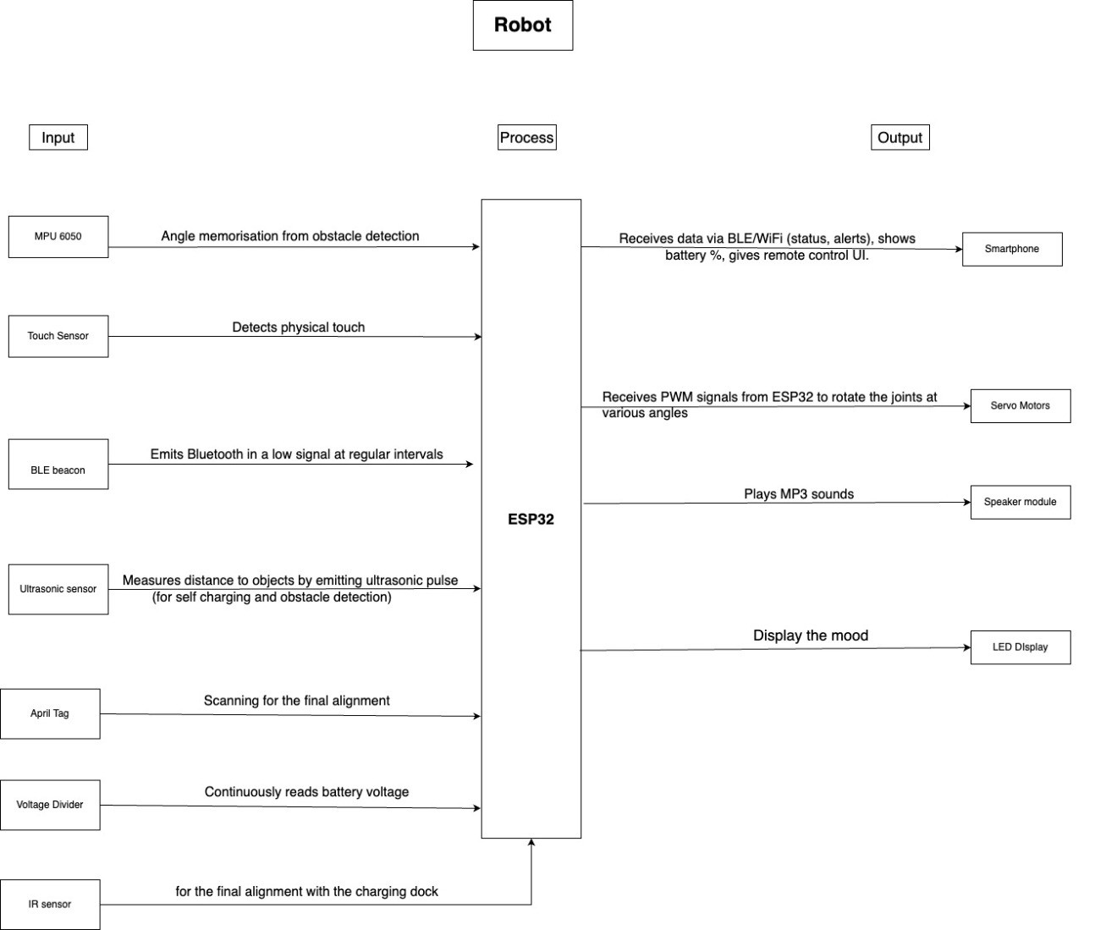
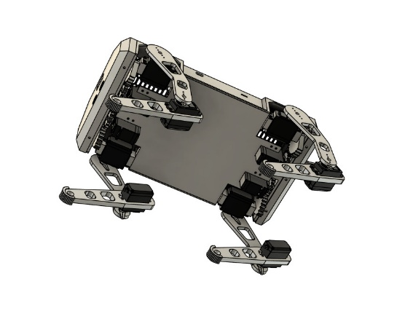
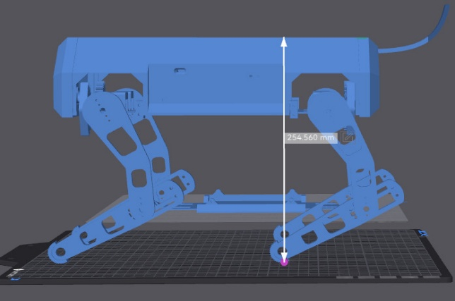
4.2 - 3D view of the output:
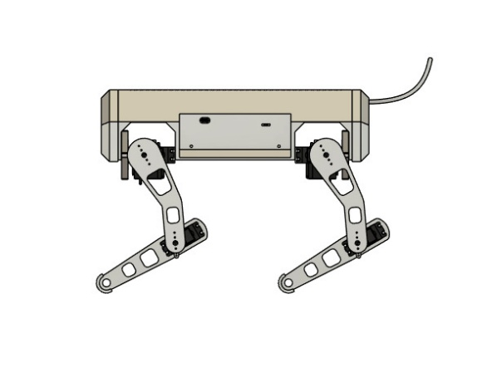
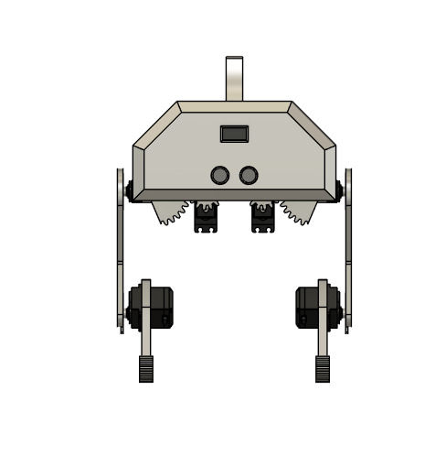
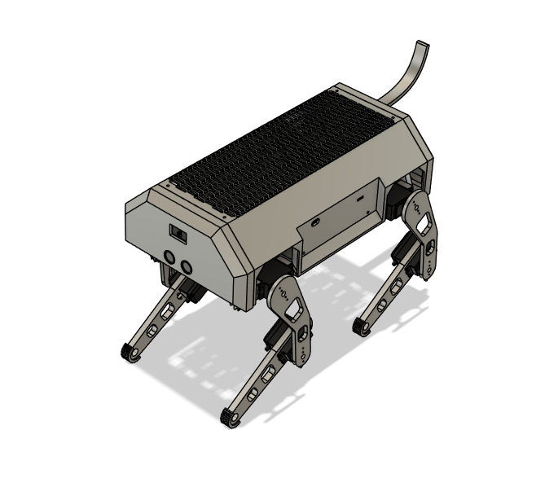
4.3 -Circuit Diagram:

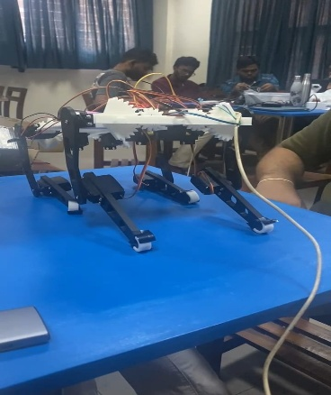
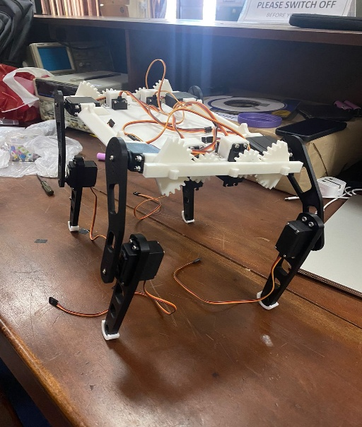
4.4 -Project Procedure:

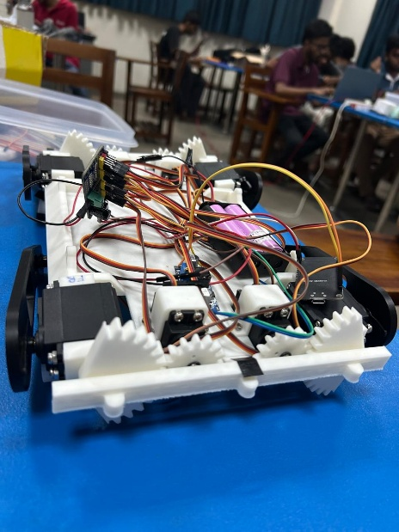
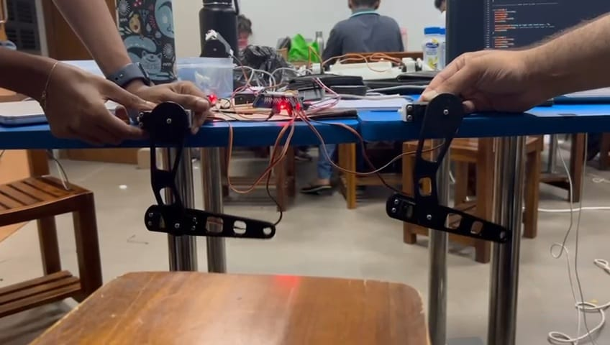
5.Components and Used Technologies
Component | Purpose
ESP32 Dev Kit V1  (ESP-WROOM-32) | Central microcontroller for processing gestures and commands
MPU-6050 Sensor | Detects hand gestures via motion (accelerometer + gyro)
Touch sensor | Detects physical touch
HC-SR04 Ultrasonic Sensor | Detects nearby obstacles and triggers barking
IR sensor | Alignment with the charging dock
BLE beacon (IR emitters) | Emits Bluetooth in low signal at regular intervals
MG90S Servo Motors | Controls robot dog's leg movements (forward/backward)
SG90 Servo Motor | Tilts the tail to express behavior like barking
Servo Motor Driver Module (PCA9685) | Controls multiple servos efficiently
DF Player Mini MP3 Module | Plays barking sound and music using audio files
Mini 8Ω 3W Speaker | Outputs audio (bark sound and music)
microSD Card | Stores MP3 audio files for DFPlayer
3.7V Li-ion Battery Pack | Main power source for the Hand Glove unit and the robot dog
LM2596 Buck Converter | Converts 7.4V battery power to 5V for ESP32 and other modules
Voltage Divider | Continuously reads battery voltage
OLED display | Display emotions
Breadboard | Assembling the circuit
Jump wires | Connects and powers all components
April tag | Scanning for the final alignment
Robotic Dog frame(3D printed) | Main Body frame to mount the components

6.Work Distribution

Member | Role | Responsibilities
245006E | Gesture Glove & Microcontroller | Microcontroller: ESP32 setup for glove, MPU 6050 integration, Gesture interpretation, Connecting ESP32s via local networking (BLE/Wi-Fi).
245009P | Robot movements & Servos | Servo Motor Controlling: Develop servo gait logic, timing control, PWM signal generation, and motor wiring/soldering.
245087B | Obstacle Detection and self-charging | PIR/Obstacle Detection: Interfacing and coding for all robot sensors (Ultrasonic, IR Sensor, HC-SR501, Touch Sensor), data analysis, and obstacle avoidance logic.
245066K | Coding | App Development/Coding: Building the App structure, remote control UI, handling wireless communication, and coding robot outputs (RGB LED, Speaker module, LED Display for mood).
245095X | Structure, Power & System Testing | PCB Designing, Power Supply, Chassis, Testing: Power supply design (Voltage Divider for battery monitor), Chassis setup, Self-charging procedure (if implemented), and final system integration, debugging, and error correction.

